Self- directed study: Balance Assessment Practice
Case Study 1
Observe the front and back pictures of Mr AB below and describe what you would write in his case note below:
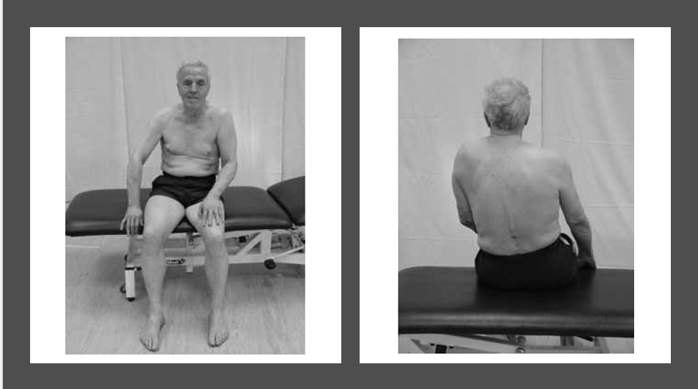
Posture

Case Study 2
Patient C is an 80-year-old gentleman that you are reviewing in your Older Person’s Assessment Clinic. He has been referred by his GP as he has had a couple of falls indoors, one in the shower and the other when going to the bathroom in the night.
PMH: Type 2 diabetes, Total hip replacement x 2 (2010 - L, 2016 – R), macular degeneration and a heart failure
SH: Lives with wife, house with stairs, retired accountant. Previously attended a group exercise class in his local leisure centre once a week however has been closed since the pandemic.
Question
- Pick 3 functional assessments to complete with this gentleman and explain your clinical reasoning behind each one
- What do you think might be limiting his balance and putting him at greater risk of falls

Case Study 3
Patient D is a 65-year-old retired teacher who has had her confidence knocked when out shopping recently she fell in the street. She didn’t sustain any injuries however has lost her confidence significantly and stayed indoors ever since.
PMH: Hypertension
SH: Lives with husband, usually very active and attends the local gym twice weekly to swim.
Question
- Pick 3 functional assessments to complete with this lady and explain your clinical reasoning behind each one.

